Examination #3 Bio 308-General Microbiology—Spring 2014 Steiner
If there appears to be more than one answer, choose the BEST ANSWER (Chapters 16-24).

1. Which of the following is NOT considered as an innate host defense?
A. skin and mucous membrane
B. saliva and gastric juices
C. phagocytic cells
D. complement
E. all of the above are considered as innate host defenses (if you consider all of the above to be considered as innate host defenses, choose this answer).*

2. Most defensins, which are found in mucous, function by ________________.
A. inhibiting protein synthesis
B. inhibiting RNA synthesis
C. inhibiting DNA synthesis
D. punching holes in the plasma membrane*
E. none of the above

3. Which of the following metabolic products ARE NOT USED by macrophages to kill ingested microbes?
A. hydrogen peroxide
B. nitric oxide free-radical
C. transferrin*
D. hypochlorite ions
E. all of the above metabolic products are used by macrophages to kill ingested microbes (if you believe that all of the above are utilized to kill ingested microbes choose this answer).

4. Which of the following is NOT typically associated with interferon:
A. activation of immune cells such as natural killer cells
B. punch holes in viral envelopes*
C. interfere with viral replication
D. can result in certain host symptoms such as aching muscles and fever

5. Which of the following is NOT typically associated with the complement cascade?
A. inflammation
B. opsonization
C. triggering interferon production*
D. membrane attack complexes

6. Colostrum- (first mother’s milk) is considered as:
A. artificially acquired adaptive immunity
B. naturally acquired passive immunity*
C. naturally acquired adaptive immunity
D. artificially acquired passive immunity

7. An area on an antigen molecule, to which an antibody molecule binds, is called (choose the BEST answer):
A. light chain
B. heavy chain
C. epitope*
D. Fc fragment

8. Cell mediated immunity is most effective in defending against which of the following?
A. toxins
B. viruses before they enter cells
C. virus infected cells*
D. circulating bacteria

9. Cells that synthesize and release antibody molecules are termed:
A. granulocytes
B cytotoxic T lymphocytes
C. plasma cells*
D. helper T lymphocytes

10. Cells that are neither T or B cells, but function to non-specifically kill cells infected by viruses are called:
A. Macrophages
B. Neutrophils
C. Natural killer cells*
D. Memory cells

11. The figure below depicts ________________.
A. how B cells are activated
B. how T cells are activated
C. how we prevent our immune system from attacking our own tissues*
D. how we rid ourselves of ineffective lymphocytes during embryogenesis

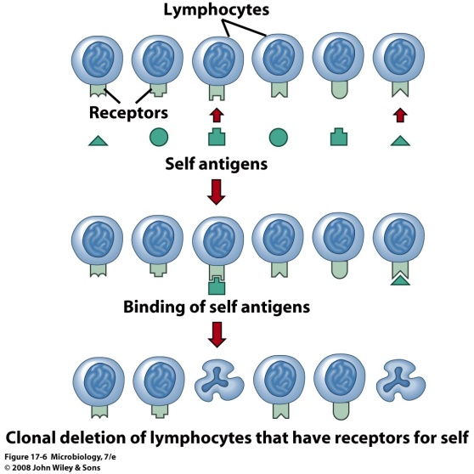

12. Which of the following “shuts off” antibody production?
A. T_{H} cells (helper T cells)
B. Tc cells (cytotoxic T cells)
C. Ts cells (suppressor T cells)*
D. memory T cells

13. Which pair correctly matches the hypersensitivity reaction with its type?
A. immediate (type I) – immune complexes
B. cytotoxic (type II) -- anaphylaxis
C. immune complex (type III) – precipitation of antigen-antibody complexes*
D. cell-mediated (type IX) – blood transfusion

14. Allergens bind to sensitized mast cells resulting in cross-linking of ____ molecules which in turn leads to degranulation.
A. IgG
B. IgB
C. IgM
D. IgE*

15. To treat generalized anaphylaxis, _________ must be administered immediately.
A. histamine
B. epinephrine*
C. prostaglandins
D. ibuprofen

16. Which of the following is an example of respiratory anaphylaxis?
A) the tubercles of tuberculosis
B) Legionnaire's pneumonia
C) Hay fever
D) Asthma*

17. The blocking antibodies formed in response to allergy desensitization are composed of which class of antibody?
A. IgG*
B. IgD
C. IgA
D. IgM

18. A mother who is blood type B has antibody against A. She can conceive a baby with blood type AB (if the father is type A for example). She need not worry about her antibody destroying the fetal AB blood cells (the baby in utero) because her antibody against A:
A. has a very low titer
B. is of the IgM class of antibodies*
C. is of the IgG class of antibodies
D. sees the babys blood cells as “self” and therefore does not react against them

19. Type IV hypersensitivity involves
A. B cells
B. complement
C. immune complexes
D. T cells*

20. Examples of autoimmune diseases include which of the following?
A. systemic lupus erythematosus
B. myasthenia gravis
C. rheumatoid arthritis
D. all of the above*

21. Which condition is most likely to lead to erythroblastosis fetalis
A mother Rh positive, father Rh negative
B. mother Rh negative father Rh positive*
C. both mother and father Rh positive
D. both mother and father Rh negative
E. two of the answers above (if you believe that two of the above answers are correct choose this answer).

22. Myasthenia gravis
A) involves autoantibodies that are against the acetylcholine receptors*
B) involves immune complexes which initiate inflammation in joints
C) mainly affects the glomeruli of the kidney
D) involves antibodies against DNA

23. Which of the following is NOT considered as an immune complex disorder?
A. serum sickness
B. Arthus reaction
C. systemic lupus erythematosus
D. asthma*
E. all of the above are considered as immune complex disorders (if you believe that all of the above are considered as immune complex disorders, choose this answer).

24. Which of the following definitions of tissue transplants is incorrect?
A. autograft -- tissue is moved from one part of the body to another
B. allograft -- tissue is grafted between two individuals who are not genetically identical
C. xenograft -- tissue is grafted from one animal species to another
D. isograft -- tissue is grafted from parent to child*
E. All of the above definitions are correct (if you believe that all of the above definitions are correct, choose this answer).

25. Which of the following are not considered as type IV hypersensitivities?
A. contact dermatitis
B. granulomatous hypersensitivity
C. erythroblastosis fetalis*
D. tuberculin hypersensitivity

26. The major organism associated with gaseous gangrene is:
A. Staphylococcus aureus
B. Streptococcus pyogenes
C. Clostridium difficile
D. Clostridium perfringens*
E. Pseudomonas aeruginosa

27. This organism is associated with ophthalmia neonatorum and is also the leading cause of preventable blindness
A. Haemophilus influenza biogroup aegyptium
B. Neisseria gonorrhoeae
C. Chlamydia trachomatis*
D. Staphylococcus aureus
E. Streptococcus pyogenes

28. Which of the orgnisms listed in question 27 causes scarlet fever?
A. B. C. D. E.*

29. Which of the orgnisms listed in question 27 causes scalded skin syndrome?
A. B. C. D.* E.

30. Which of the following is the prime cause of life-threatening infections following burns?
A. Propionibacterium acnes
B. Staphylococcus aureus
C. Streptococcus pyogenes
D. Pseudomonas aeruginosa*
E. Escherichia coli

31. ___________ is responsible for 80 percent of the cases of pyelonephritis- inflammation of the kidney
A. Propionibacterium acnes
B. Staphylococcus aureus
C. Streptococcus pyogenes
D. Pseudomonas aeruginosa
E. Escherichia coli*

32. Toxigenic strains of ______________ are responsible for toxic shock syndrome
A. Propionibacterium acnes
B. Staphylococcus aureus*
C. Streptococcus pyogenes
D. Pseudomonas aeruginosa
E. Escherichia coli

33. In addition to some viral infections, glomerulonephritis is often caused by:
A. Propionibacterium acnes
B. Staphylococcus aureus
C. Streptococcus pyogenes*
D. Pseudomonas aeruginosa
E. Escherichia coli

34. Which of the following accounts for more than one-half of all infections that make couples infertile?
A. Treponema pallidum
B. Ureaplasma urealyticum*
C. Neisseria gonorrhea
D. Chlamydia trachomatis

35. In class we discussed the fact that early studies suggesting that herpes simplex virus is associated with cervical cancer might be flawed. This was because the researchers were unaware of infections due to __________ during that study.
A. Cytomegalovirus
B. Chlamydia trachomatis
C. human papilloma virus*
D. Neisseria gonorrhea

36. The type of wasting destruction that occurs in the brain or cardiovascular system (among other organs) as shown below as occurring in the skin, is associated with:
A. Neisseria gonorrhea
B. Treponema pallidum*
C. Chlamydia trachomatis
D. herpes simplex virus

37. I am a bacterium that infects the respiratory tract. I produce a toxin when I am infected with a prophage that carries an exotoxin producing gene. Major adverse signs often follow my disease, such as myocarditis (inflammation of the myocardium of the heart), and polyneuritis(inflammation of multiple nerves). Moreover, significant cardiac abnormalities occur in 20 percent of patients. Who am I?
A. Streptococcus pyogenes
B. Streptococcus pneumonia
C. Pseudomonas aeruginosa
D. Corynebacterium diphtheria*
E. Mycoplasma pneumonia

38. Which of the organisms listed in question 37 is responsible for primary atypical pneumonia?
A. Streptococcus pyogenes
B. Streptococcus pneumonia
C. Pseudomonas aeruginosa
D. Corynebacterium diphtheria
E. Mycoplasma pneumonia*

39. Which of the following would you NOT CONSIDER as a most common causal agent of inner ear infection (otitis media)?
A. Streptococcus pyogenes
B. Streptococcus pneumonia
C.Legionella pneumonphila*
D.Hemophilus influenza

40. In the USA, more deaths result from pneumonia than from any other infectious disease. Moreover, of the various organisms that cause pneumonia, ___________ is the most prevalent cause of pneumonia

A. Klebsiella pneumonia
B. Mycoplasma pneumonia
C. Streptococcus pneumonia*
D. Hemophilus influenzae
E. Legionella pneumophila

41. Before 1900, approximately one-third of adults died of ___________ before reaching old age. Today this organism is showing signs of again becoming a problem because of its growing resistance to antibiotics
A. diphtheria
B. pneumonia
C. tuberculosis*
D. whooping cough
E. tetanus

42. I am a vaccine made of only the capsular polysaccharide. Against which of the diseases in question do I protect?
A. diphtheria
B. pneumonia*
C. tuberculosis
D. whooping cough
E. tetanus

43. Because of this organism, imported parrots cannot be sold in the US without sufficient quarantine.
A . Coxiella burnetii
B. Chlamydia psittaci*
C. Chlamydia trachomitis
D Respiratory syncytial virus

44. Which number in the figure below of the influenza virus indicates the structure that determines whether the virus is influenza A, B , or C?
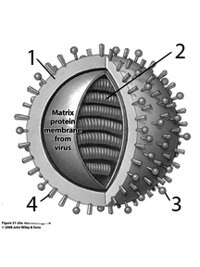
A. 1 B.2* C. 3 D. 4
45. I am a virus and the most common and most important cause of viral pneumonia particularly in male infants 1 to 6 months old. Major outbreaks in nurseries generally result in fatalities, whereas I generally produce mild symptoms in adults.
A. herpes simplex virus
B. severe acute respiratory syndrome ( SARS)
C. respiratory syncytial virus (RSV)*
D. influenza virus

46. The distinctive structure surrounding the virus, to which it derives its species name, below indicates that this virus is which of the viruses indicated below?
A. herpes simplex virus
B. coronavirus*
C. respiratory syncytial virus (RSV)
D. influenza virus
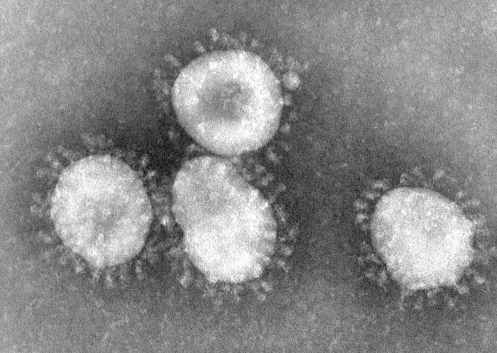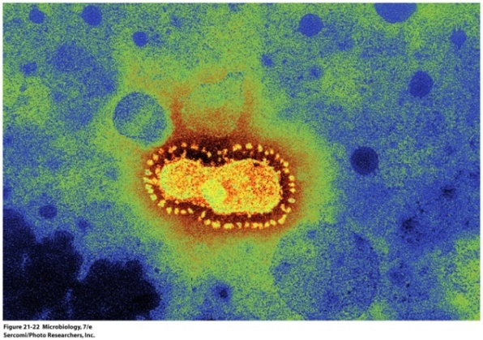

47. I am an oral organism often associated with periodontal disease.
A. Streptococcus mutans
B. Paramyxovirus
C. Porphyromonas gingivalis*
D. Mycoplasma hominis

48. This organism causes severe diarrhea and may result in bloody stools. In fact, this organism is the leading cause of bacterial diarrhea reported in the United States:
A. Campylobacter jejuni*
B. Salmonella enteriditis
C. Shigella dysenteriae
D. Escherichia coli 0157
E. Salmonella typhi

49. Which of the following organisms listed in question 48, are most likely to cause a fatal infection because the organism is able to spread to all internal organs.
A. Campylobacter jejuni
B. Salmonella enteriditis
C. Shigella dysenteria
D. Escherichia coli 0157
E. Salmonella typhi*

50. Which of the following organisms causes food poisoning due to a food intoxication rather than a food infection?
A. Campylobacter jejuni
B. Salmonella enteriditis
C. Shigella dysenteria
D. Staphylococcus aureus*
E. Helicobacter pylori

51. Which of the organisms in question 50 is responsible for ulcers?
A. Campylobacter jejuni
B. Salmonella enteriditis
C. Shigella dysenteria
D. Staphylococcus aureus
E. Helicabacter pylori*

52. If you contracted acute nonbacterial enteritis, say in a cruise ship, the likely causative agent would be?
A. Rotavirus
B. Norwalk virus*
C. Hepatitis C virus
D. Hepatitis A virus

53. Which of the diseases is diagnosed by a serological test which is characterized by the ability of the patient’s blood to agglutinate sheep red blood cells (termed heterophile antibody).
A. Dengue fever virus infection
B. Yellow fever virus infection
C. infectious mononucleosis*
D. hepatitis A

54. Which of the following is NOT one of the major causes of bacterial meningitis?
A. Neisseria meningitides
B. Streptococcus pneumonia
C. Mycoplasma pneumonia*
D. Listeria monocytogenes

55. In pregnant women this organism can cross the placenta, infect the fetus and cause abortion, still birth or neonatal death. It is responsible for many cases of fetal damage.
A. Neisseria meningitides
B. Streptococcus pneumoniae
C. Mycoplasma pneumoniae
D. Listeria monocytogenes*

56. Which of the following organisms causes the characteristic bull’s eye rash shown below?
A Franciscella tularensis
B. Brucella recurrentis
C. Borrelia burgdorferi*
D. Yersinia pestis
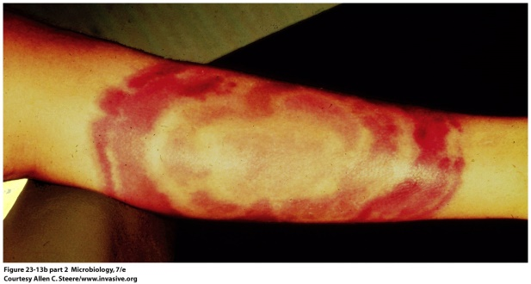

57. A recent study suggests a possible reason that autism is more prevalent in males. That reason can be summarized as:
A. Two X chromosomes carry a double dose of genes that protect the fetus against autism
B. Girls tolerate neurodevelopmental mutations better than boys do*
C. Elevated estrogen is somewhat protective against genetic abnormalities
D. The female fetus develops slightly later than does the male fetus

58. A recent study suggests that ____________ may increase the risk for atrial fibrillation
A. beta-blockers
B. statins
C. Non-steroidal anti-inflammatory drugs*
D. diuretics

59. The European commission is beginning the biggest ever stem cell trial to determine whether or not stem cells can be used to treat ____________
A. osteoarthritis
B. damaged hearts*
C. Alzheimer’s damaged brain tissue
D. myelin sheath damage associated with multiple sclerosis
E. inflammatory bowel disease

60. A recent study suggests that drinking milk can slow the progression of ___________?
A. osteoarthritis*
B. damaged hearts
C. Alzheimer’s damaged brain tissue
D. myelin sheath associated with multiple sclerosis
E. inflammatory bowel disease

61. A recent study reports that developmental aspects of the ______________ are influenced by bacterial colonization of the gut:
A. Cardiovascular system
B. Nervous system
C. Adaptive immune system*
D. innate immune system

62. A recent article suggests that in treating urinary tract infections in men __________.
A. at the onset, no treatment should be done
B. a shorter treatment (e.g., 7 days) is better than longer a treatment (21 days)*
C. a longer treatment is better than shorter treatment
D. sulfa drugs should be used instead of antibiotics

63. According to the CDC’s Morbidity and Mortality Weekly Report measles cases:
A. have shown a substantial decrease and, in fact, are the lowest in 20 years
B. have not changed for the past 20 years
C. are the highest in 20 years*
D. are slowly declining

64. ___________ is the most prevalent and most rapidly growing sexually transmitted bacterial disease
A. Treponema pallidum
B. Ureaplasma urealyticum
C. Neisseria gonorrheae
D. Chlamydia trachomatis*

