BIO 510 Exam I NAME (please print) ____________________________________________________

Open Book 20 points total: NEB paper catalog only, no text, notes or electronic devices

1. (10 points) Starting with 1 microgram (µg) of supercoiled plasmid pMAL-p5X (NEB page 352) create a set of directional overlapping deletions that start in the multiple cloning site (MCS) and progress rightward (unidirectional) toward the malE gene. Condition: In your response, you are not allowed to use PCR or chemically make synthetic DNA.
Describe each of the enzymatic steps required to prepare the DNA up to the point of E. coli transformation (you do not have to describe E. coli competent cell preparation or the transformation procedure). Name the enzyme, tell what purpose it serves, list the buffer that you will use. In addition, be sure to describe any steps needed after an enzymatic reaction to prepare the sample for the next step in the protocol (for example, to get rid of enzyme #1 activity prior to presenting enzyme #2).

Here we might use the ExoIII (buffer on NEB page 115) to create 3’-5’ ssDNA deletions on PstI (buffer on NEB page 57) and BamHI cut (buffer on page 24) plasmid. The BamHI site is sensitive to ExoIII deletion, the PstI site is not (as it has a recessed 3’ end). After staggered time points (e.g., 5 min., 10 min. 15 min.) remove a portion of the sample & stop the & clean up as indicated below. Next blunt the ends with mung bean nuclease (buffer on NEB page 116), clean up, then circularize the blunted linear DNA with T4 DNA ligase (buffer on NEB page 106) – the sample is ready for transformation

Cleanup after each enzymatic reaction: add TE to 150 µl, PCI extract, then precipitate with sodium acetate and ethanol. Resuspend the pellet in water.

2. (2 pts) Which bacterial mutation(s) listed below (and described on NEB pages 336-337) would you include in your E. coli background to clone human genomic DNA? Why would you select this (these) marker(s)? In your response be specific in telling how the mutation helps – and why your experiment would be less likely to succeed.
a) xyl, b) thi-1, c) hsdR, hsdS, d)tsx, e) mcrA, mcrBC.

Use mutants hsdR, hsdS and mcrA, mcrBC to protect against E. coli degradation due to inappropriate methylation of the genomic DNA.

3. (2 pts) Which enzymes pairs (that is, sets of 2 different enzymes) produce DNA ends that can always be directly ligated together? Choose all that are compatible (Note: there may be more than two). A description of the enzyme recognition sequences is found on NEB p305.
a) EgeI, b) FauI, c) FauDI, d) FaiI, e) FaqI

Only the blunt end cutters work (EgeI & FaiI)

4) (1 pt) You have 2 µg of plasmid DNA but only one half unit of restriction enzyme. Which of the following restriction enzymes would you choose to most likely cleave the plasmid to completion (choose only one)? Assume all have cleavage sites in your plasmid & that methylation patters do not matter. What is the basis of you selection?
a) MmeI b) BamHI, c)BsiEI, d)HpyCH4III, e) NciI

HpyCH4III shows the best survival under reaction conditions (NEB 312) and retains most of its activity over 8 hours. So, although you do not have much of the enzyme, if you allow the reaction to continue & get 0.5 µg cut per hour, you should get full digestion after of the 2 µg of DNA in ~ 4 hours of incubation.

5) (5 pts) Provide the sequence for two 18 nucleotide single-stranded oligonucleotide primers that can be used to precisely remove the EcoRV site (but add or remove nothing else) from the pGLuc-Basic 2 plasmid (NEB 350) by inverse PCR. Be sure to present both sequences in the 5’-3’ orientation.
Primer sequence #1 (5’->3’): CTC GAG CCC AAG CTT GGT
Primer sequence #2 (5’->3’): TGC AGA ATT CCA AGA TCT (this one needs to be directed outward against the opposite strand of primer #1)

BIO 510 Exam I NAME (please print) ____________________________________________________

Closed Book (80 points)
1. (2.5 pts – circle the 5 correct answers in parentheses). Radiation from 32-P is in the form of a (beta,) particle which can promote the release of (X-ray) irradiation when it strikes (thin,) foils of (high) atomic number materials. 32-P is best shielded by (1/2 inch Plexiglas).

2. (2 pts) Many storage and reaction buffers for enzymes contain dithiothreitol (DTT). If a mistake is made and DTT is not added, which is the one most likely consequence?
b. the enzyme will form undesired intermolecular and intramolecular covalent bonds

3. (3 pts) Present the following reagents in the appropriate order of addition in the E. coli plasmid “mini-prep” experiment
a) 200 mM NaOH, 1% SDS
b) 3M Potassium acetate ( made by mixing 300 ml of 5M potassium acetate with 57.5 ml of glacial acetic acid and 142.5 ml of sterile water)
c) 100% ethanol
d) Phenol/Chloroform/Isoamyl alcohol (PCI)
e) 50 mM glucose, 10 mM EDTA, 25 mM Tris-HCl, pH 8.0
f) 10 mm Tris, 1 mm EDTA (TE) with ribonuclease

Order of addition: 1(first)___F__ 2__A___ 3__B___ 4__D___ 5_C____ 6(last)___F___

4. (4 pts) What is the function of:

a) f1(IG)? Origin of replication for ssDNA synthesis on the pTZ vector activated by M13K07

b) rep(pMB1)? Origin of replication for dsDNA synthesis on the pTZ vector

c) MCS? Multiple cloning site – lots of restriction site cloning options for the pTZ vector

d) bla(Ap^{R})? The gene that encodes beta lactamase, an enzyme that cleaves ampicillin to make the pTZ transformed bacteria drug resistant

In your answer state what the gene or DNA sequence does and how we used it in our BIO 510 lab experiments.
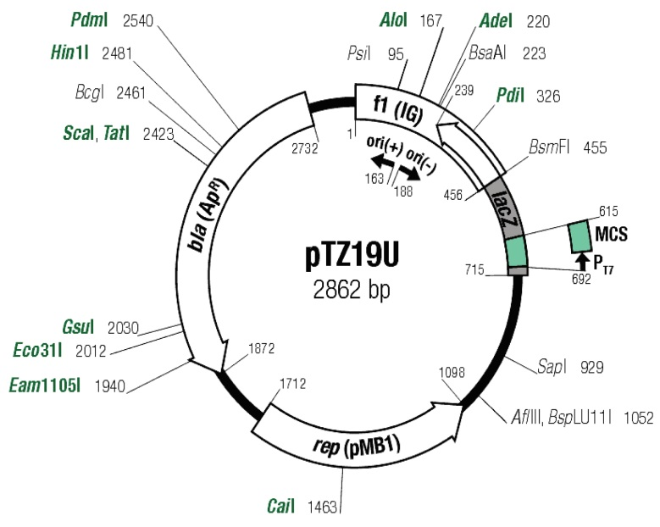

5. (12 pts) Using the following hybridization data, determine the location and direction of transcription for the four RNA transcripts. GIVEN: Assume that no more than one transcript is present in any interval defined by two adjacent restriction sites (that is, BamH1 to Pst1, Pst1 to Tsp1, Tsp1 to Msp2 etc.) and that no transcripts extend into an adjacent restriction fragment. Put an arrow head at the 3’ end of the transcript (5’ -> 3’) and be sure to indicate clearly by a solid line labeled with a transcript length where each transcript resides and label its size.

Single stranded Probe (5’->3’) Hybridizing Bands on Blot (all in kb)
BamH1-> Cla1 1.7 kb, 1.0 kb
Msp2-> Pst1 3. kb
BamH1-> Msp2 1.7, 1.0
Cla1-> BamH1 3.1 kb, 0.8 kb
Pst1->Gas1 1.0
Tsp1-> BamH1 0 kb
Pst1->Msp2 1.0
GasI->Msp2 0

BamH1--<1.7---Pst1--<1.0----Tsp1-------3.1>-----Msp2--------------Gas1---------0.8>---------Cla1

6. (3 pts) A scintillation counter provides a measure of radioactivity in CPM values.
a) What do the letters CPM represent? counts per minute; what the scintillation counter registers
b) What do the letters DPM represent? decays or disintegrations per minute; actual radiation decay
c) How do you convert CPM values into DPM values? What factors guide you in this conversion? CPM X counting efficiency = DPM; the counting efficiency depends on the isotope used and the sensitivity of your scintillation counter

7. (1 pt) You want to maximize the difference in relative mobility of supercoiled vs linear versions of a plasmid DNA. To do this, you should run an agarose gel in (3X) TAE buffer.

8. (3 pts) Treatment of DNA with EcoRI methylase will (decrease) the ability EcoRI restriction endonuclease to cleave DNA? Treatment of DNA with Dam methylase will most often (decrease) restriction endonuclease cleavage efficiency at substrate sites bearing this modification? Plasmid DNA methylated by Dam methylase will (poorly) transform yeast lacking the Dam methylase (This should have said bacteria rather than yeast; everyone gets credit for this part of question 8)?

9. (14 pts) Which of the following would be useful for (put letter alongside process): 1) purification of DNA _A__2) creation of unidirectional DNA deletions with Exonuclease III __G__, 3) use of EcoRI methylase _C___, 4) suppressing background in your northern blot hybridization, __B___5) use of E. coli DNA ligase__D____ 6) staining DNA for UV visualization__F_____, 7) transcriptional induction of the lacZ gene E
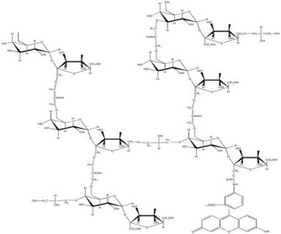
A)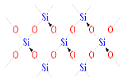 B)
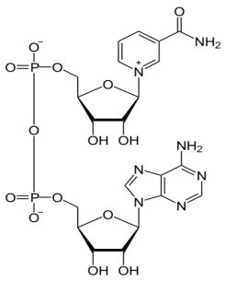
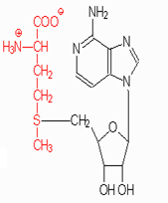

C) D)

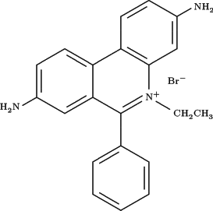
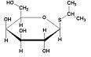

E.
F)

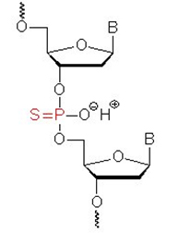

G.

10. (3 pts) Four bench mates independently transformed E. coli with 10 ng of ligated pTZ18u DNA and obtained the following results on ampicillin plates plated with the same amount of cells & DNA:

Bob: blue colonies (42), white colonies (645)
Cheryl: blue colonies (490), white colonies (197)
Ted: blue colonies (687), white colonies (390)
Jim: blue colonies (0), white colonies (113)

Assume that for all three students, 100% of the DNA was ligated into circular forms prior to transformation and no satellite colonies appear on the plates. A) Which student had the best transformation efficiency? Ted

B) What is your rationale for this selection (that is, why did you select this student)? Both white and blue colonies are transformants and Ted had the greatest number.

11. (2 pts) Starting out with a single double-stranded genomic DNA template and sufficient primers, enzyme and all other co-factors for successful PCR, predict how may PCR products with ends defined by both primers exist after 4 cycles of PCR? By this I mean that you count only double stranded molecules that begin and end at the primer binding sites but lack any other genomic DNA. For the purposes of this question ignore the terminal transferase activity of Taq DNA polymerase (that is, assume that this activity is not relevant). You do not have to draw out the images (although you are welcome to do so if this helps you) but show the math used to obtain this answer. 2^{n}-2n = 8

12. (2 pts) For gels running at constant voltage, increasing the salt concentration of the running buffer (increases) the current and (decreases) the resistance of the electrical circuit? Current is read in units of (amperes) and resistance is read in (Ohms)? (circle correct answers)

13. (2 pts) What are satellite colonies of E. coli and how do these form on an agar plate? Satellite colonies form from untransformed cells that grow in the vicinity of a true transformant because the beta lactamase secreted from the transformant lowers the level of ampicillin to a sub-bacteriostatic level.

14. (3 pts) What is the difference in function between type I and type II topoisomerases and how do the co-factor requirements differ?
Topoisomerase II (DNA gyrase) uses ATP to add negative supercoils (to relax the positive supercoils produced during replication & transcription) –it introduces double-stranded DNA breaks followed by gyrase-mediated re-ligation to remove neutralize the positive supercoils introduced during replication or transcription. Topoisomerase I relaxes negative (or positive) supercoils it; it produces a single-stranded nick in one strand to unwind and then reseals. Removes supercoiling to enhance separation of DNA strands upon completion of replication. Topo I activity (E. coli TopA gene product) does not require ATP.

15. ( 4 pts) A) Define the following (what these are) and B) provide an example of each and state how each used each in our BIO 510 experiments.
i) Promoter site: A DNA sequence where RNA polymerase binds to initiate transcription. We used several. For instance the T7 promoter on the pTZ vector for in vitro transcription of our riboprobes; the lacZ promoter on pTZfor blue/white screen; the Gal4-sensitive promoters for our yeast two-hybrid study, the promoters of any other genes used for selection in yeast or bacteria (e.g., LEU2)
ii) chromogenic substrate: A compound that changes color when acted upon by an enzyme. For instance, X-gal was used in our blue/white screen for insertional inactivation of lacZ.

16. (1 pt) A) FALSE ATP is a required co-factor for E. coli DNA ligase. B) TRUE In most cases of laboratory use, ATP is a required co-factor for T7 RNA polymerase.

17. (3 pts) Discuss three different product features that should be considered when comparing competing reagents for use in the BIO 510 lab (as we did when considering the use of ethidium bromide vs Sybr Safe). Cost, sensitivity & safety (e.g., toxicity or mutagenicity)

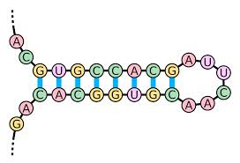
18. (5 pts) From lecture discussion and assigned reading. Starting with this RNA molecule, draw the structures (using A, C, G, U lettering as below) after treatment with:
5’ end

1. T7 RNA polymerase = no change

2. Cobra Venom nuclease (ribonuclease VI)
dsRNA bases removed; ssRNA intact
3. Mung Bean nuclease: ssRNA removed, dsRNA intact

4. Exonuclease III = no change
3’ end
5. RNase A = cleaves 3’ of C & U (though simple removal of all ssRNA will get partial credit)
3’ end

19. (2) What is “nested PCR”? In your response, be clear A) how the experiment is performed and B) under what conditions you might want to do nested PCR (that is, why you might choose to use this approach) Nested PCR is conducted by performing two sequencing PCR experiments. In the first, a complex DNA template is used (e.g., human genomic DNA) with a distal set of primers flanking the site to be amplified. In the second round, a small amount of the first PCR product is used as a template with a second pair of primers that are proximal to the desired target (that is, within the region amplified by the first set). Next PCR is often used when the results of a primary amplification contain many secondary products resulting from off-target amplification.

20. (3 pts) Plasmids isolated from E. coli have (negative) supercoils introduced by the enzyme DNA gyrase or topoisomerase II to relieve the torsional stress on the DNA introduced by (replication).

21. (1.5 pts) Yeast transformation differs from E. coli transformation in that denatured salmon sperm DNA (improves) yeast transformation efficiency. M13K07 is a filamentous (virus) that infects (E. coli, Saccharomyces cerevisiae).

22. (2 pts). The yeast two-hybrid system detects (protein-protein) interactions (in vivo). Independent of the specific study involved, the system makes use of a split gene for a yeast (transcription factor) that, in the case of a successful two-hybrid interaction the pair of fusion proteins interact through the sequences linked to the Gal4 DNA binding and activation domains expressed from pAS2 and pACT2, respectively. This results in the transcriptional activation of a Gal4 dependent reporter gene in the host yeast strain (e.g., GAL1-HIS3)

23. (2 pt ) What was the most valuable scientific concept, application, or procedure learned in the first half of BIO 510. Credit given only for thoughtful constructive comments.

All students receive 2 extra credit points for the class discovery of the SGD pattern match program glitch.

