BIO 510 Exam I –open book (NEB catalog only) NAME (please print)_________________

1. (2.5 pts) You want to use PCR to produce a linear double-stranded DNA. Both oligonucleotides primers for PCR must begin (at the 5’ ends) with the same 6 base pair restriction endonuclease site. After gel purification you need to cut the PCR product with the restriction enzyme that recognizes the sequence present in the oligonucleotide-defined DNA ends. You have the option to use the either ApaI, HindIII, NcoI, or SalI restriction sites in the oligonucleotide primers. Assume that each of these primers works efficiently for PCR
A. Which enzyme would be the best to use for your cloning experiment?
B. Why would you select this enzyme?

2. (2.5 pts) Dr. Rapidpace wants you to prepare 1 microgram of linear pTXB1 plasmid (page 348). You have only one unit of enzyme and one microgram of supercoiled plasmid and must have the linear DNA ready in 1 hour You have the option to use any ONE of the following enzymes: EcoRI, SalI, XhoI or SapI.
A. Which enzyme would be the best to use?
B. Why would you select this enzyme?

3. (2.5 pts) You need to ligate a linear plasmid DNA with a DNA fragment. Both DNAs were cut with the same restriction endonuclease. However, you ran out of phenol and have no chemical of enzymatic substitute to remove your restriction endonuclease from the DNA digestion. You have the option of using any one of the following enzymes for cleavage: ApeKI, BcoDI, HinDIII or BglII. Assume that a) each of the four restriction endonucleases produces plasmid & insert DNA with appropriate ends for ligation (that is, the digestion pattern is fine for your experiment and b) any one of the four restriction enzyme digestion buffers will be compatible with T4 ligase activity by the simple addition of 0.5 mM ATP.
A. Which enzyme would be the best to use?
B. Why would you select this enzyme?

4. (3 pts) You want to convert plasmid pUC19 (page 350) into a vector that can be used to produce single-stranded DNA and transform both yeast and E. coli. What genes or other DNA elements must be added to pUC19 to accomplish this? Be specific in your answer (e.g., provide the names of any genes you want to add).

5. (2.5) You want to clone human genomic DNA into plasmid pUC19 and transform E. coli. You can use either strain BR111 (F’ ΔproAB, thi-1) BR222 (ΔproAB, thi-1), BR333 (ΔproAB, thi-1, ΔhsdR) or BR444 (F’ΔproAB, thi-1, ΔDam). Note: the strain names are made up (not in the NEB catalog) and the symbol “Δ” means that the indicated gene is fully deleted.
A. Which E. coli strain would be the best to use?
B. Why would you select this strain?

BIO 510 Exam I –closed book NAME (please print)_________________________________

1. (2 pts) Define “ionizing radiation”. Be specific in your response & be sure to tell what is ionized.

2. (1 pt) Provide one example of ionizing radiation.

3. (2 pts) Very thin high density foils (such as lead) absorb the high energy (alpha, beta, gamma; circle one) particle emitted from ³²P but are not recommended for use as shielding due to the resulting Bremsstrahlung radiation. What is Bremsstrahlung radiation?

4. (3 pts) One problem in freezing bacteria is that ice crystals can form during the freezing process and, as water expands upon freezing, the ice causes the cells to lyse (break), killing the bacteria. How did we prevent ice crystal formation during freezing when we prepared TG1 E. coli competent cells?

5. (5 pts) Describe the reaction mechanism of T4 DNA ligase. Be detailed in your answer and be sure to describe the specific function of ATP.

6. (2 pts) What is the role of the buffer (such as Tris-HCl) in a restriction enzyme’s digestion solution?

7. (3) Discuss three different properties of a buffer that you would consider before using it in an enzymatic reaction. Assume that the buffer is pure and not contaminated with any other materials.

8. (1 pt) You want to minimize (that is, reduce) the difference in mobility between supercoiled DNA and linear DNA of the same length. To do this, you might run an agarose gel in (0.3X, 1.0X or 3X; circle one) TAE buffer.

9. (3 pts) Three bench mates independently transformed E. coli with 10 ng of ligated pTZ18u DNA and obtained the following results on ampicillin plates plated with the same amount of cells & DNA:

Bob: blue colonies (42), white colonies (645)
Cheryl: blue colonies (197), white colonies (490)
Ted: blue colonies (687), white colonies (390)

Assume that for all three students, 100% of the DNA was ligated into circular forms prior to transformation. Which student had the best transformation efficiency? What is your rationale for this selection (that is, why did you select this student)?

10. (12 pts)
Given the following hybridization data, determine the location and direction of transcription for each RNA transcript. Assume that no more than one transcript is present in the interval defined by two adjacent restriction sites (that is, EcoRI to PstI, PstI to BglII, BglII to KpnI) and that no transcripts extend into an adjacent fragment. Put an arrow head at the 3’ end of the transcript (5’ -> 3’) and be sure to indicate clearly by a solid line labeled with a transcript length where each transcript resides and its size.

Single stranded Probe (5’->3’) Hybridizing Bands on Blot (all in kb)
EcoRI –> PstI 1.5
BglII - >KpnI no bands
KpnI ->BglIII 0.79, 1.8
Pst-Kpn no bands
PstI->EcoRI 0.79

EcoRI BglII PstI KpnI

11. (8 pts) Match the solution below with the letter best corresponding to function in the E. coli miniprep procedure. Match each solution with only one function by placing the correct number along the function..
1) 200 mM NaOH, 1% SDS
2) 1 ml 100% ethanol
3) 100 µl 50 mM glucose, 10 mM EDTA, 25 mM Tris-HCl, pH 8.0)
4) 300 µl phenol:chloroform:isolamy alcohol (50:49:1)
5) 150 µl 3M potassium acetate (made by mixing 300 ml of 5M potassium acetate with 57.5 ml of glacial acetic acid and 142.5 ml of sterile water).
6) 1 ml 80% ethanol
7) 30 µl TE with RNase A
8) 200 µl chloroform

a) dissolves DNA pellet and degrades co-purifying RNA___
b) removes residual phenol from the aqueous layer___
c) lyses the E. coli cells___
d) precipitates the nucleic acids___
e) removes residual salt from the ethanol precipitate___
f) resuspends the cells in an osmotically stable environment before lysis___
g) removes protein in a two-phase patrician with the cell lysate___
h) precipitates proteins for removal before to the use of organic solvents___

12. (2 pts) For our northern blot experiment, which of the following are expected to increase the stringency of hybridization – that means, which steps are expected to reduce the likelihood that the probe will be retained by short regions of base pairing with non-target mRNAs? CIRCLE ALL THAT APPLY.
i. reduce the temperature of the hybridization, ii., add formamide to the hybridization solution, iii, remove DTT from the wash solution, iv increase the sodium chloride concentration in the wash buffer, v increase the temperature of the hybridization
13. (1 pt) Treatment of DNA with EcoRI methylase will (increase, decrease, or not influence; circle one) the ability EcoRI restriction endonuclease to cleave DNA?
14. (4 pts) In what way are bacterial restriction/modification systems similar to the immune system of mammals?

15. (14 pts) Which of the following would be useful for (put letter alongside process): 1) purification of DNA ___2) creation of unidirectional DNA deletions with Exonuclease III ____, 3) use of EcoRI methylase ____, 4) suppressing background in your northern blot hybridization, _____5) use of E. coli DNA ligase______ 6) staining DNA for UV visualization_______, 7) transcriptional induction of the lacZ gene
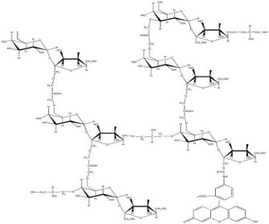
A)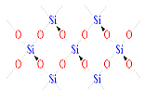 B)
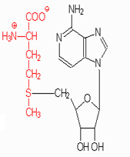
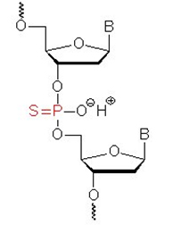
C) D)

E. 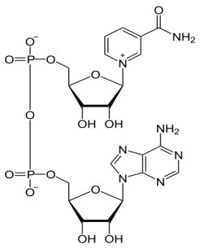F. 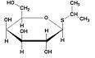G. 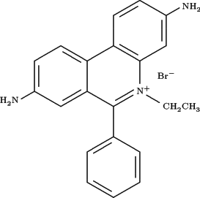

16. (5 pts) Describe in detail the substrate and reaction products of each enzyme:
- McrB/C nuclease

- T4 RNA ligase

- DNA gyrase

- DICER nuclease

- Mung bean nuclease

17. (2 pts) Starting out with a single double-stranded genomic DNA template and sufficient primers, enzyme and all other co-factors for successful PCR, predict how may PCR products with ends defined by both primers exist after 4 cycles of PCR? By this I mean that you count only double stranded molecules that begin and end at the primer binding sites but lack any other genomic DNA. For the purposes of this question ignore the terminal transferase activity of Taq DNA polymerase (that is, assume that this activity is not relevant). Show your work (that is, how you arrived at this answer)

18. (2 pts) You calculated the change in Gibbs free energy value ΔG associated with the folded structure of a natural tRNA and one that you arbitrarily altered by nucleotide substitution. You found that the ΔG value (increased or decreased; circle the correct answer) after nucleotide substitution indicating that the “mutated” version was (more or less; circle the correct answer) stable.

19. (2 pts) Define each of the terms (that is, what do the letters stand for) in the following equation for the Gibbs free energy calculation:
ΔG = ΔH- T ΔS

20. (5 pts) When using C. elegans in an RNAi experiment, we simply added E. coli to the nematode. (5 pts) How did the E. coli addition direct degradation of specific target mRNAs (e.g., CLF1, DPY-1 etc.) within the animal? In your response describe both the role of the E. coli and the mechanism of RNAi within the C. elegans animal.

21. (2 pts) Match the RNAi knockdown target with the best description of the observed phenotype compared to the control. Each gene gets a phenotype and each phenotype should be used only once.
Target: a) CLF1________, b) unc-22________, c) dpy-1 ________, d) L4440 ________

Phenotype: 1. Great lethality (death) in second generation, 2) no change, 3) twitchy movement and animals held in clusters (look like they were stuck together), 4) short, thick-bodied adults

22. (2 pts) In measuring the amount of radioactivity in a sample, we considered both CPM and DPM.

What do the letters in the abbreviations CPM and DPM stand for?

How are CPM values related to DPM values?

23. (1 pts) TRUE or FALSE (circle one). ATP is a required co-factor for E. coli DNA ligase.

24 (3 pts) Discuss three product features that should be considered when comparing competing reagents for use in the BIO 510 lab (as we did when considering the use of ethidium bromide vs Sybr Safe.

