BIO 510 Exam I, NEB Open book NAME:_________________________________

1. (4 pts) From lab experiments & discussion. You want to convert plasmid pUC19 (page 350) into a vector that can be used to both a) produce single-stranded DNA and b) transform both yeast and E. coli. What genes or other DNA elements must be added to pUC19 to accomplish this? Be specific in your answer (e.g., provide the names of any genes or DNA elements you want to add and tell what purpose the added DNA serves in the newly designed shuttle vector). The requirements for bacterial selection and propagation are already present. At the minimum, you need to add a single-stranded DNA replication origin (e.g., the F1 origin), a yeast origin of replication (of the YEP variety from the yeast 2 micron circle or the YRP variety from a natural yeast chromosome) plus a selectable marker gene for yeast transformation (e.g., TRP1, LEU2, URA3). Leaving out the replication origin is ok as long as you say that you will integrate the plasmid into the yeast genome.

2. (2 pts) From lecture discussion & assigned reading. You want to a transfer plasmid bearing a human DNA gene insert out of E. coli strain NEB 5-alpha (page 207) where it is currently propagated and transform into the NEB dam-/dcm- E. coli strain (also on page 207).
a) Do you expect the transformation efficiency into dam-/dcm- E. coli to be high or low (assume proper competent cell preparation)? Explain your answer. DAM/DCM modification is a mark for replication. See below
b) What if you did the converse experiment and wanted to transfer this same plasmid successfully propagated in the NEB dam-/dcm- E. coli into the NEB 5-alpha strain. Do you expect the transformation efficiency? Explain your answer.
Methylated DNA is a signal for replication. Fully unmethylated DNA can be replicated once but arrests replication in the hemi(that is, half)-modified state until the newly synthesized strand is methylated. Transfer of fully methylated plasmid from NEB 5-alpha into the dam-/dcm- background results in replication arrest and poor transformation efficiency. Transfer of the plasmid from the unmethylated from dam-/dcm- into the NEB 5-alpha background presents no problem for propagation since the methylation activities are present and can modify the transformed DNA (high transformation efficiency).

3. (1 pt) From lecture discussion & assigned reading. You have only one unit of restriction enzyme, one microgram of supercoiled plasmid DNA isolated from E. coli, and one hour to complete the enzymatic reaction. Which of the following enzymes will be your first choice to achieve 100% cleavage? Only SmaI cuts the supercoiled DNA sufficiently well to meet your experimental demands.

4. (7.5pts). From lab experiments, discussion and assigned reading.You want to change the Tomet gene shown below such that protein synthesis initiates at the third ATG within the protein coding sequence (shown below). The gene is already cloned into the correct gene expression vector which is a circular plasmid called pET166 (hint-no need to change the vector backbone). All the DNA sequences required for efficient transcription and translation are present in this construct upstream of the first ATG codon. Design an experiment in which you change Tomet gene structure in such a way that protein synthesis now begins at the third ATG in the protein coding portion of this gene. NOTE: the coding strand is shown (in 5’-3’ orientation) of the implied dsDNA. The capital case letters are protein coding sequence. The first, second and third ATGs are underlined and highlighted.

If using a PCR approach, write out the specific DNA sequences (in 5’-3’ polarity) for each oligonucleotide used. Describe each enzymatic step needed to go from the current construct to the modified form ready for transformation into E. coli (you do not need to describe the E. coli transformation protocol).

Do inverse PCR as conducted in our lab using Taq polymerase + dNTPs and a forward primer with a 5’ end at the “A” in the third ATG in same polarity as the strand provided (e.g.,5’ATGTTAAAAAAGCTGCG3’) and a reverse primer corresponding to the COMPLEMENT of the sequence provided and having a 5’ end abutting the 1st ATG (e.g., 5’ AGATGGACAGGTACAATTT 3’). Next blunt the inverse PCR product with mung bean nuclease to remove the “extra” A that Taq polymerase adds. Finally, phosphorylate the PCR fragment with T4 polynucleotide kinase +ATP and ligate the plasmid ends together with T4 DNA ligase + ATP. gtcaaattgtacctgtccatctATGAAGTTGGATGACTTTATGTTAAAAAAGCTGCGCAATGAGCAGGTTACCATAGAACTAUAA
M K L D D F M L K K L R N E Q V T I E L *

BIO 510, Exam I, Closed book exam questions NAME_______________________
5. (2 pts) From lab experiments, discussion.What was the purpose of adding salmon sperm DNA to your northern blot hybridization experiment (be specific). The salmon sperm served as a blocking agent that saturated the membrane sites not already bound by the yeast RNA. This prevented the 32P-labeled riboprobe from sticking directly to the membrane (but still allowed the riboprobe to base pair with the yeast RNA on the membrane).

6. (2. pts) From lab experiments, discussion and assigned reading. How does M13K07 promote the production of single stranded recombinant pTZ19u DNA? The M13K07 virus infects TG1 and during its replication cycle produces the proteins needed to activate the F1 origin of single stranded DNA replication present on the pTZ19u plasmid as well as the M13K07 replication origin. M13K07 also encodes virion proteins exit proteins needed for the single stranded pTZ19u to be secreted from the bacteria.

7. (1pt) From lecture discussion. In what way is interspecies horizontal gene transfer similar to recombinant DNA technology? Horizontal gene transfer occurs when DNA/genes from one organism are transferred into an unrelated organism thus creating a new genotype. While the pieces of DNA moved by horizontal gene transfer are random (though may be subject to natural selection), recombinant DNA approaches do this by intentionally picking and choosing which pieces of DNA to combine in which organisms.

8. (5 pts) From lecture discussion. The most common state of natural DNA is the (B) form which is a (right)-handed helix. Double stranded RNA is typically found in a (A) form which is a (right)-handed helix. Z-DNA helices are (left)-handed helix.

9. (3 pts) From lecture discussion. Label each helix type (A, B or Z):

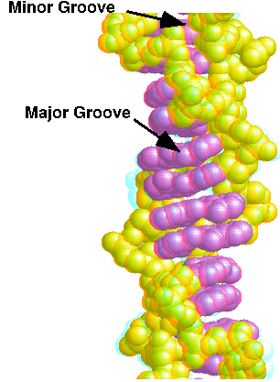__Z___ 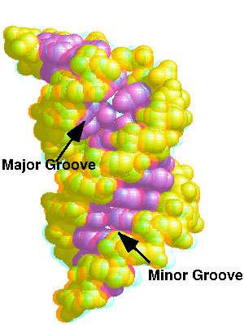___A__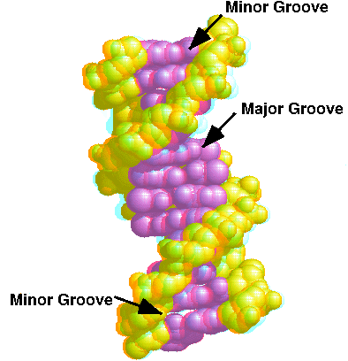__B__

10. (4 pts) From lecture discussion. What is the predicted frequency of cleavage for each of the following enzymes?
5’GAATTC3’ ___1/4096_____
5’PuTTCAAPy3’ ___1/4096_____
5’TGAGTTT(N)₁₃ 3’ ____1/16,384____
5’NNNANNNG3’ ____1/16____
Pu = purine; Py = pyrimidine; N= any nucleotide

11. (3 pts) From lecture discussion and assigned reading. The EcoK restriction modification system is composed of 3 protein-coding genes, hsdM, hsdR, hsdS. What is the function of each of the encoded proteins? Be specific & define terms as needed.
hsdM? This is the DNA methylase associated with the EcoK system
hsdR? This is the DNA endonuclease associated with the EcoK system
hsdS? This is the DNA specificity (targeting) factor associated with the EcoK system

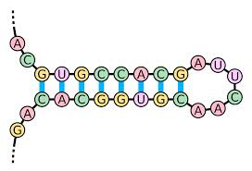
12. (9 pts) From lecture discussion and assigned reading. Starting with this molecule, draw the structure (using A, C, G, U lettering as below)
after treatment with mung bean nuclease; after treatment with exonuclease III; after treatment with cobra venom nuclease. For each case, I want the structure after treatment with that enzyme only (not combinations of the three enzymes).

MUNG BEAN NUCLEASE (only) Mung bean nuclease removes the single strands (both the internal loop and the single-stranded 5’ and 3’ ends)

EXO III (only) Not a substrate, does not change the molecule.

COBRA VENUM NUCLEASE (only) Cleaves double stranded region – diagram as retaining only the single strands currently in the loop and ends.

13. (5 pts). From lab experiments, discussion and supplemental reading. Discuss 4 different features of a buffer that you would consider before using it in your experimental application. In your response, tell why each is important to consider. The buffer must act in a pH range acceptable for your reaction; must be stable under the incubation conditions; should not interfere with the chemistry planned; if using tissue culture, should not be toxic; other issues (e.g. pH change with temperature, cost of purchase, environmental toxicity, etc.)

14. (4 pts) From lecture discussion. Dr. Nubitz suspects that the rat Htep cell line expresses 15-fold more Blt1 mRNA than found in rat liver, kidney, heart or brain. Outline an experiment to test this hypothesis using an RNA protection assay. In your response, describe how the experiment is performed, how the results will be obtained, and how you will interpret your results. See the class PowerPoint slides for details. In essence, make a radiolabeled probe of complementary RNA longer than the target. Anneal the probe to mRNA isolated from the desired sources. Cut the hybrids with single strand specific nucleases then resolve the products on a gel. The intensity of the protected band is proportional to the mRNA abundance.

15. (5 pts) From lecture discussion. What is the TUNEL assay? How is it performed? What questions are answered by this assay? Transferase BrdUTP Nick End Labeling, or TUNEL is an assay for apoptosis (regulated cell death) done in tissue culture or with tissue samples. The basis of this technique is that during apoptosis, genomic DNA gets nicked and fragmented. The newly formed ends of DNA can be labeled with terminal transferase & bromodeoxyuridine 5´-triphosphate. An antibody exists against the bromouridine which can be used to detect the sites of the nicks. Tissues with high levels of apoptosis show lots of antibody-dependent staining.

16. (3 pts) From lab experiments, lecture discussion. Describe the mechanism by which ATP promotes DNA ligation in vitro. Be very clear which specific chemical steps ATP the added ATP participates in. ATP is first ligated to a side chain lysine in the ligase molecule, releasing ppi. Next the AMP is transiently joined to the 5’ phosphate of the DNA strand to be ligated. The adjoining 3’ hydroxyl of the DNA then attacks the di-phosphate bond resulting in the release of AMP (& ligase) and ligation of the DNA.

17. (3 pts) From lecture discussion. What are microRNAs (miRNAs)? How are they processed? How are miRNAs believed to regulate gene expression? miRNAs are expressed from endogenous genes by RNA polymerase II to produce long partially double stranded RNAs. These are then sequentially processed by the DROSHA and Dicer enzymes to produce 21-23 nt guide RNAs loaded into the RISC complex. The guide RNAs direct RISC to mRNAs by imperfect base pairing (often in the 3’ untranslated region). The binding of miRNAs to mRNA reduces translation and may enhance mRNA decay.

18. (2 pts) From lab experiments, lecture discussion, assigned reading. Which enzyme catalyzes this reaction? This is a phosphatase reaction (e.g., shrimp alkaline phosphatise)
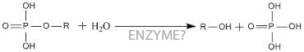

19. (2 pts) Which enzyme catalyzes this reaction? From lecture discussion and assigned reading.This is a kinase reaction (e.g., T4 polynucleotide kinase)
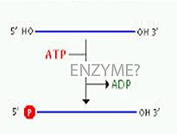

20. (2 pts) Which enzyme catalyzes this reaction? From lab experiments, lecture discussion, assigned reading.
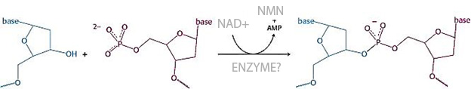E. coli DNA ligase

21. (3 pts) From lab experiments & discussion. Many restriction enzymes include both sodium and magnesium salts in the reaction buffer. While both cations stabilize protein structure, sodium but not magnesium can often be successfully substituted by an alternative cation (e.g., K+, Li+, NH4+) in the reaction. What is the reason for the stricter magnesium requirement? In addition to helping proteins fold properly, magnesium often forms a critical part of the enzymes active site and is required for the electron coordination needed for catalysis. This function often has strict steric/chemical properties preventing substitution by other ions.

22. (2 pts) From lab experiments & discussion. Suppose that you prepared 0.1 microgram of uniformly radiolabeled REF1 mRNA by in vitro transcription using T7 RNA polymerase. Which of the following would you use as the “hot” nucleotide for labeling (alpha phosphate UTP circle one)? Assume that the UTP is 3000 millicuries of P-32 per millimole of UTP and that 10 µCi (i.e., micro-Curie) of radioactivity was incorporated into your 0.1 microgram RNA. How many DPM do you expect in the 0.1 microgram of recovered sample? 1 µCi = 2.2 X 10⁶ DPM, so 10 µCi = 2.2 X 10⁷ DPM

23. (12 pts) From lab experiments & discussion Given the following hybridization data, determine the location and direction of transcription for each RNA transcript. GIVEN: Assume that no more than one transcript is present in any interval defined by two adjacent restriction sites (that is, XbaI to PstI, Pst1 to SalI, SalI to BamHI, BamHI to ApaI) and that no transcripts extend into an adjacent restriction fragment. Put an arrow head at the 3’ end of the transcript (5’ -> 3’) and be sure to indicate clearly by a solid line labeled with a transcript length where each transcript resides and label its size.

Single stranded Probe (5’->3’) Hybridizing Bands on Blot (all in kb)
XbaI –> SalI 2.1 kb
BamHI ->XbaI 0
ApaI ->PstI 3.7 kp
BamHI->ApaI 0
PstI->ApaI 0.3, 2.13 kb
PstI->XbaI 0
XbaI->BamHI 0.3, 2.1

The restriction sites are indicated below by the first letter only, e.g., X=XbaI, P=PstI etc.
X P S B A
2.1 0.3 3.7
NOTE: There was an error in the question (the highlighted 3 above) that might have caused confusion (the “3” should not have been there. All students received full credit for this question independent of response (even if no answer given). Knowing how to solve this question is important, however. Consequently, this question, modified slightly, will also be present on the final exam.
+

24. Identify each of the following 3 compounds and describe what purpose each served in the BIO 510 labs (4 pts) From lab experiments, lab & discussion, posted reading.
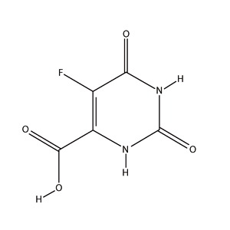
5-fluoro-orotic acid (5FOA) an antimetabolite used in our plasmid shuffle experiment to select for yeast that have spontaneously lost the URA3-containing plasmid.

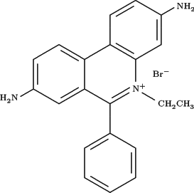
Ethidium bromide used to image DNA and RNA by UV florescence.

25. (2.5 pts) From lab experiments, lab & lecture discussion and assigned reading. Which of the following enzymes require ATP for function (circle all that apply)
- HsdR nuclease
- T4 DNA ligase
- DNA gyrase

26. (2 pts) From lab experiments and discussion. Which of the following steps is expected to increase the number of yeast transformants of YCplac33? (circle all that apply) d) addition of heat denatured single stranded DNA to the transformation mix,

27. (2 pts) From lab experiments and discussion. Which of the following steps is expected to increase the number of E. coli transformants of your properly ligated recombinant pTZ19u DNA? (circle all that apply) f) none of the above

28. (1 pt) From lab experiments, lab and lecture discussion and assigned reading. What is “supercoiled” DNA? How does supercoiled plasmid DNA form in a cell? Supercoiled DNA refers to a knotted DNA state. In E. coli DNA replication (and transcription) introduces positive supercoils which can arrest replication. DNA gyrase + ATP then relaxes this constraint by introducing negative supercoils – the plasmid is negatively supercoiled is isolated when you recover plasmid from E. coli.

29. (1 pt) From lab experiments, discussion and lab handouts. How did you make use of the oxidation/reduction of Eu and of BaFBr to acquire data from your northern blot experiment? These compounds were incorporated into our phosphorimager screen. The radiation released by the northern blot causes an oxidation of Eu+2 to Eu+3 and reduction of BaFBr to BaFBr-. The laser light used during imaging reverse this change and results in the emission of light as Eu+3 is reduced and returns to the Eu+2 ground state. This energy release is captured by the imager and presented in units proportionate to the original radiation signal on our northern blot.

30. (1 pt). From lab experiments and discussion. What words do the letters in CPM and DPM stand for? How do CPM and DPM values differ? Decays per minute (DPM) is the actual number of nuclear emissions (decays) each minute while the counts per minute (CPM) reflects the machine (e.g., scintillation counter) detection of the decays. The CPM/the detector counting efficiency = DMP

31. (2 pt extra credit) What was the most valuable scientific concept, application, or procedure learned in the first half of BIO 510. Credit given only for thoughtful constructive comments.

